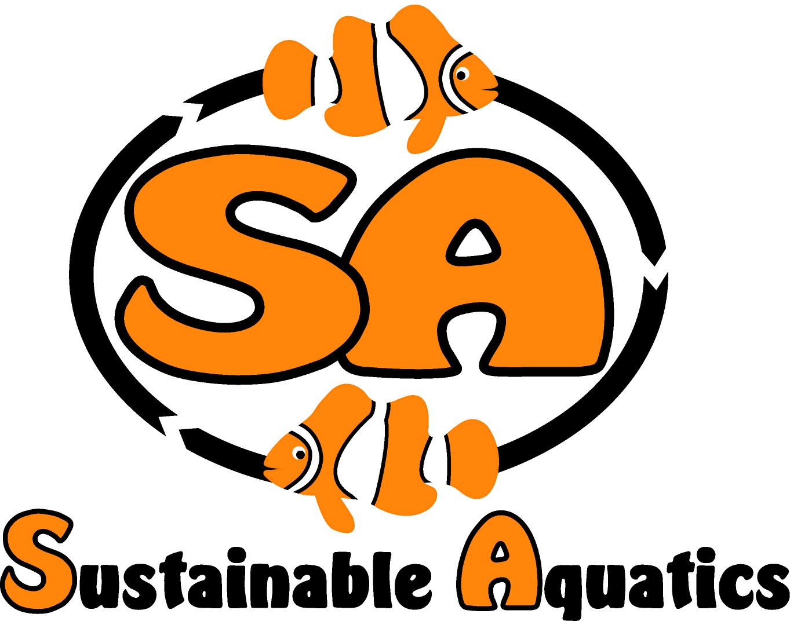 Sustainable Aquatics
110 W. Old Andrew Johnson Highway
Phone: (865) 262-0507 Jefferson City, Tennessee 37760 Fax: (865) 262-0498
8 June 2014

I am working on the declaration constitution expression for SA which I hope can contribute to the OFI effort. I want to beg your indulgence that I tend to be a first draft artist and over the years, have grown very accepting of others taking ownership of my first drafts and accepting well-meaning and well-intentioned edits, revisions and overhauls of my work. Matthew will be looking at this draft along with you and may contribute his thoughts and ideas as well. A larger community of drafters may result in a more refined and acceptable document.

Ideally, if we can draft our constitution and principles really well, we would invite all members of the community to use it not just as a member of OFI, but on their web sites and as their own declaration. And it could be a tool for recruiting new and active members.

Preamble:

It is often overlooked that Thomas Jefferson’s Declaration of Independence, as well as the framers in the Constitution of the United States, relied heavily, to the point of what might be called plagiarism on expressions contained in British Constitutional Law. They did this to structure the revolution and formation of the United States within and the context of and upon the principles of British Constitutional Law and History. The Declaration of Independence and the US Constitution would have little substance and meaning without these references.

The best example of this is Jefferson’s use of John Locke’s Second Treatise on Mankind. (http://www.constitution.org/jl/2ndtreat.htm). Also, by reference and context John Milton’s essay on freedom of speech, Areopagiticia, is a profound part of our traditions expressed and practiced in the Constitution. (http://www.gutenberg.org/cache/epub/608/pg608.txt).

In this regard we incorporate into our constitution by reference both Hardin’s The Tragedy of the Commons and Fukuyama’s Social Capital and the Global Economy.

Recognizing from history in the perspective of Hardin’s The Tragedy of the Commons that every unregulated “commons” has been destroyed by man, and that the largest commons in man’s world today is the environment, the atmosphere and the waters of the world, especially the seas, and from Fukuyama’s work that trust and context are the key to a well functioning economy and team work within the commons, our key founding principles are to manage, mitigate, avoid and correct tragedy in the commons in which we participate through data based science, good teamwork and trust and context in all things.

Declaration:

How we do what we do is more important than what we do. Our founding principle is to act in all ways to preserve, restore and expand to natural and sustainable abundance for the fair and equitable benefit of all the bounty of nature of in the seas, on the land and in the air. To preserve, restore and manage the commons while promoting and reaping the many benefits of the human animal bond:

- We must and we shall understand with science based data the nature and mechanisms of life in the sea, the reproductive strategies of the various species, their interconnectedness and interdependence, and manage with science based metrics optimally managed sustainable harvests;

- In those cases where demand for a species exceeds a sustainable harvest, we will seek to develop sustainable production in our hatcheries to complement natural harvests which are thereby maintained at sustainable levels;

- We will work towards a community approach in this regard based on the trust and context defined in Fukuyama’s work as the basis of expanding prosperity for all;

- We will use a balanced approach, such that hatchery production of fish shall be focused on complementing sustainable harvest from nature. We shall protect and promote a balanced approach to the benefit of both the livelihood of those performing sustainable harvest and those performing sustainable complementary production;

- We shall take from the sustainable nature what we need and no more, and we shall manage our needs optimally by managing our processes with harvests from the wild for highest yields possible, using science based management of data so to understand and manage the highest yields. For instance we shall not tolerate the use of cyanide collection for the reasons of its damage to the ecology, the resulting loss of animals in the supply chain and the injury done to our customers and our industry by the loss of these animals in the care of our hobbyists which they often otherwise is often not understood by them.

- We shall promote the human animal bond in its intrinsic and integral and fundamental nature and existence, both of man and the animals on earth, and we will use data based science to highlight and teach the nature and benefits of the human animal bond.

- As hatchery based research, development and production gains data based scientific insights into the reproductive strategies and life cycles of animals we shall use these insights to help manage the commons sustainably.

- In all we do as individuals and a community, we shall over time improve the commons and its management and abundance, improve the sustainable harvest and complementary sustainable hatchery production, and improve the benefits and value of the human animal bond.

- We shall observe all laws, regulations and practices as defined by law.

